Charotar University of Science And Technology

U&PU.PatelDepartmentofComputerEngineering CE

282.02Web Designing – Assignments(2020-21)

Note:ThisAssignmentisof30marks.Greatlookandfeelwithsimplicitymaygiveyougoodmarks! Keep your own contentsin your assignment.

Assignment-1

**AIM:** Create at least three HTML web pages about YOURSELF. You are to code these pages using a plain text editor such as Sublime Text, Brackets, or Atom.

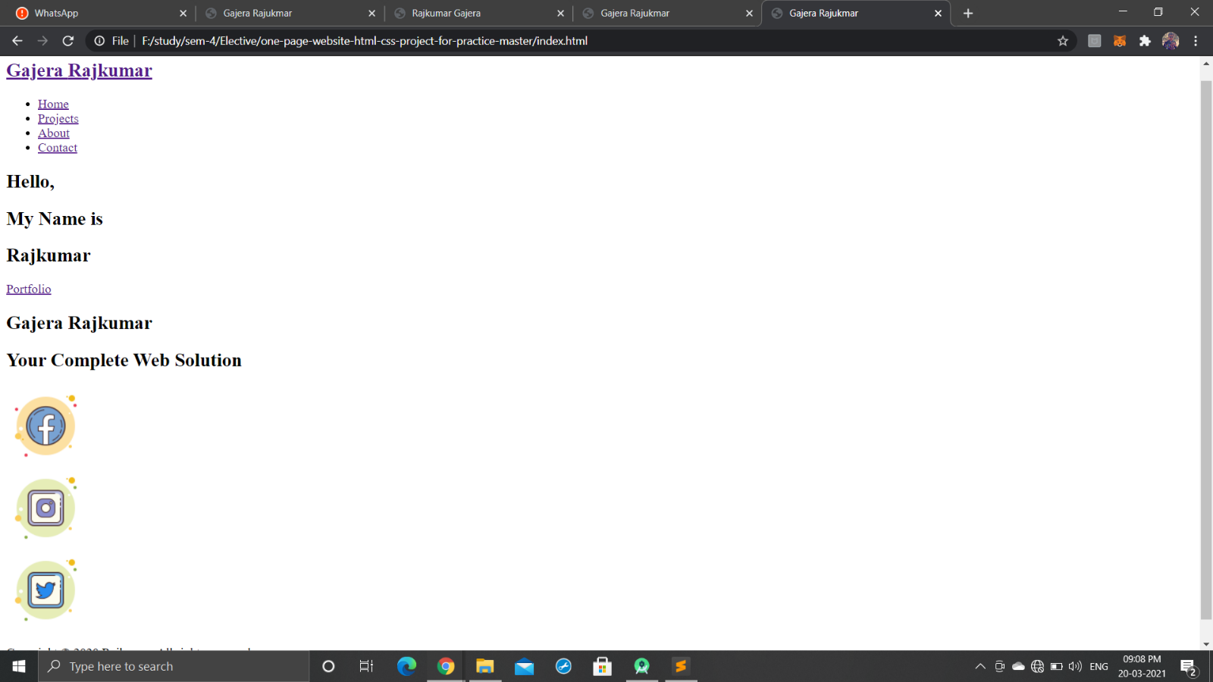

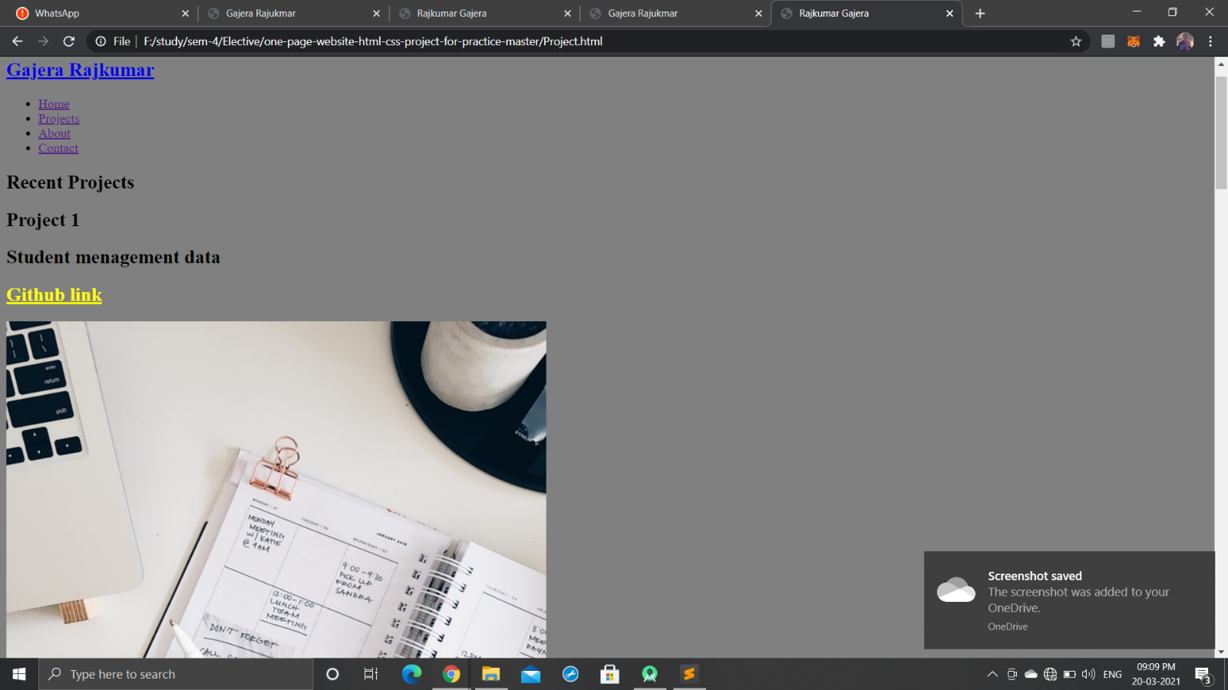

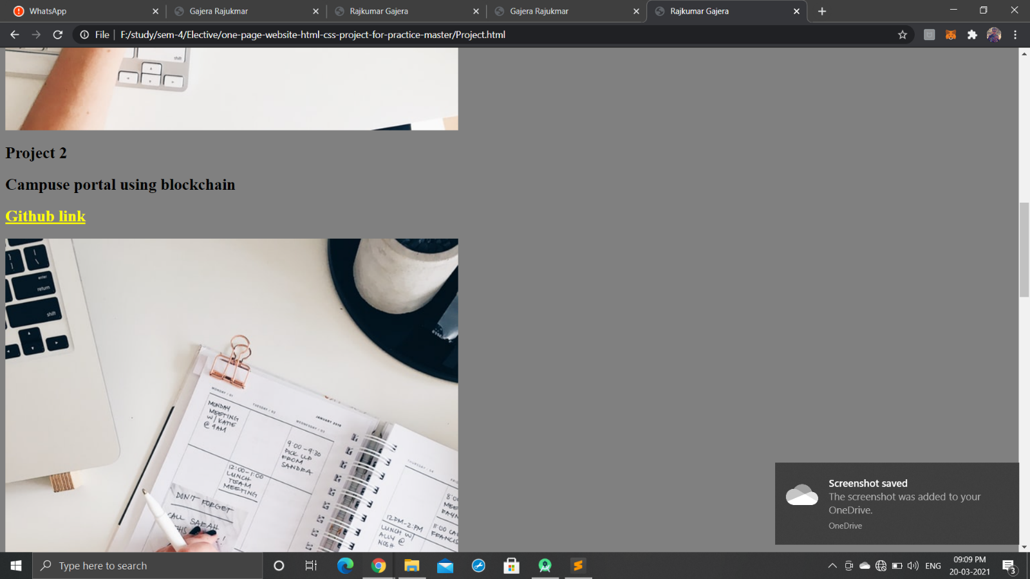



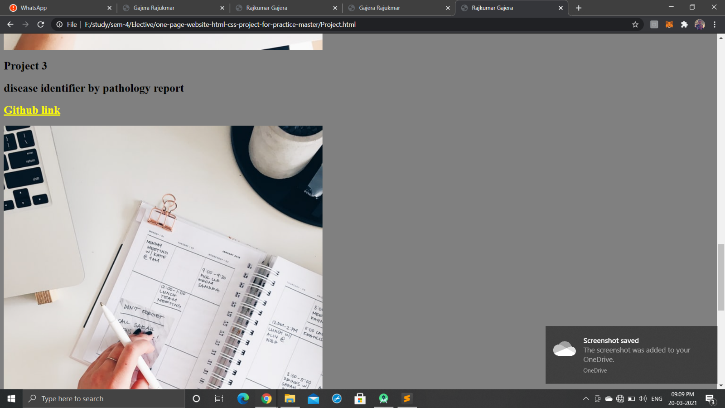

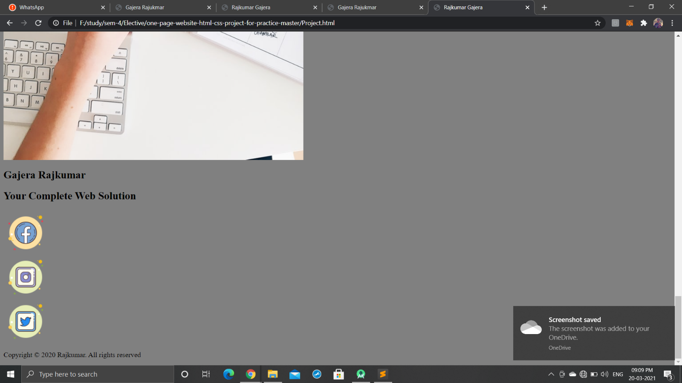

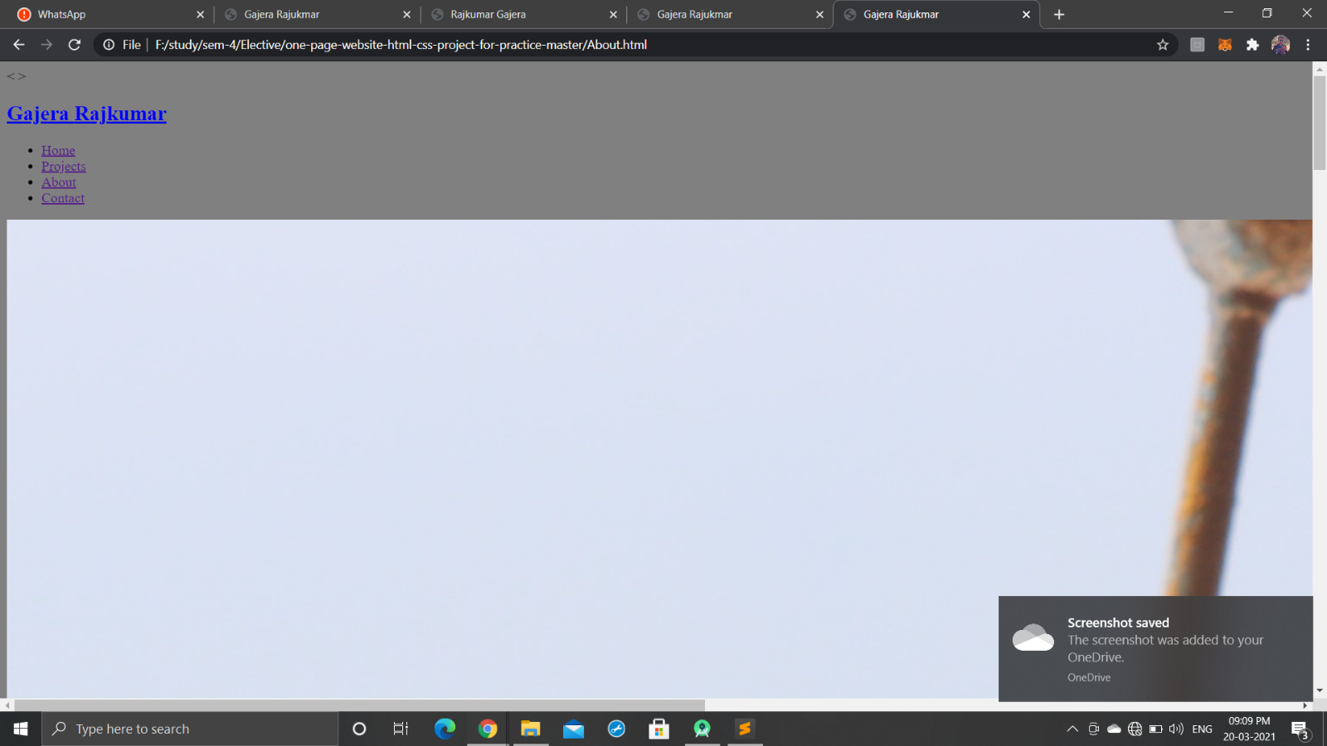

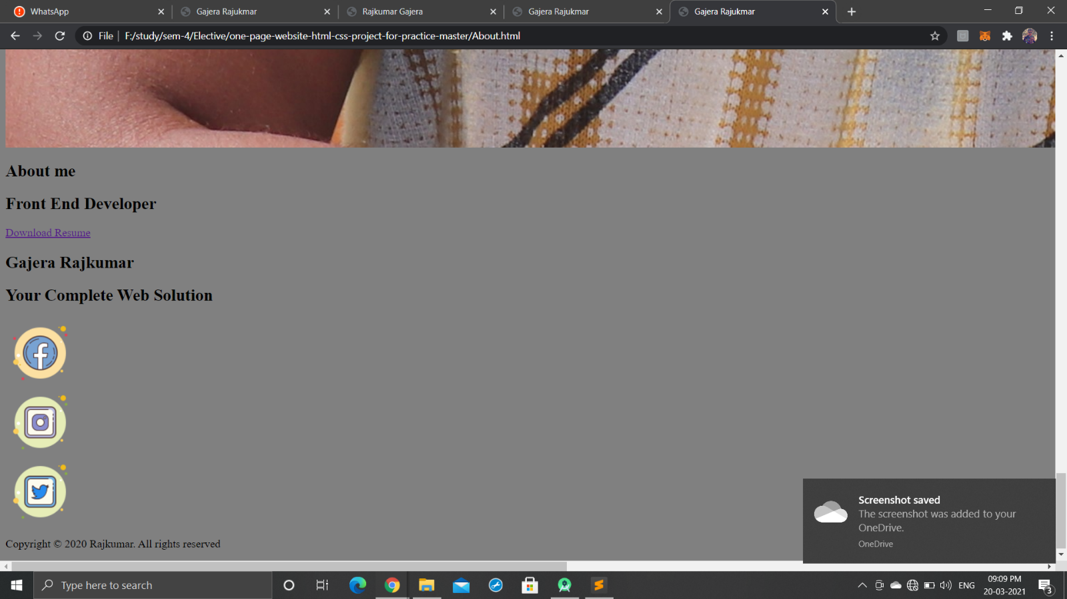

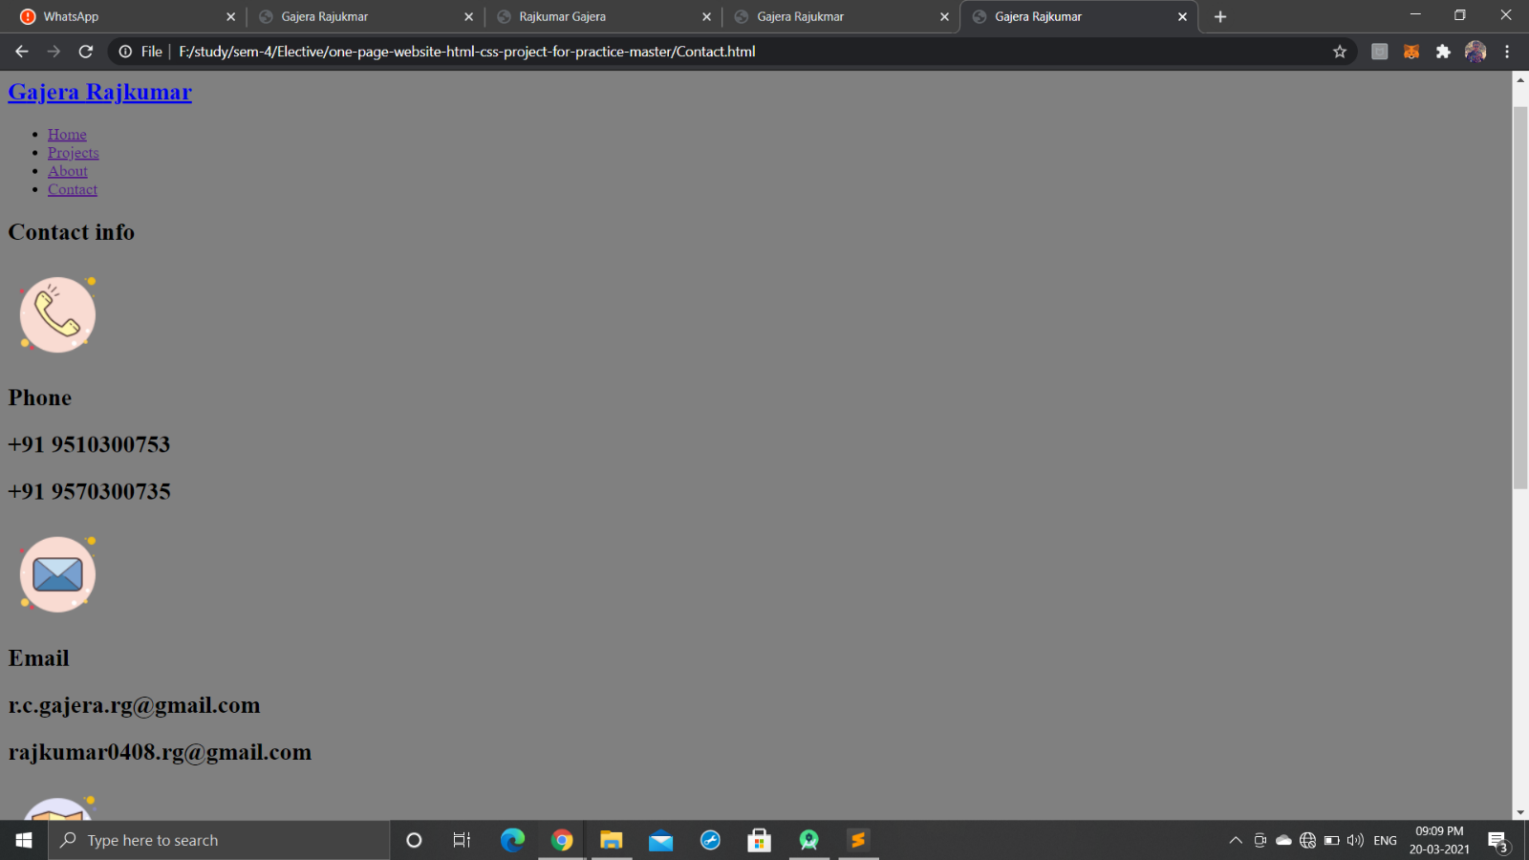

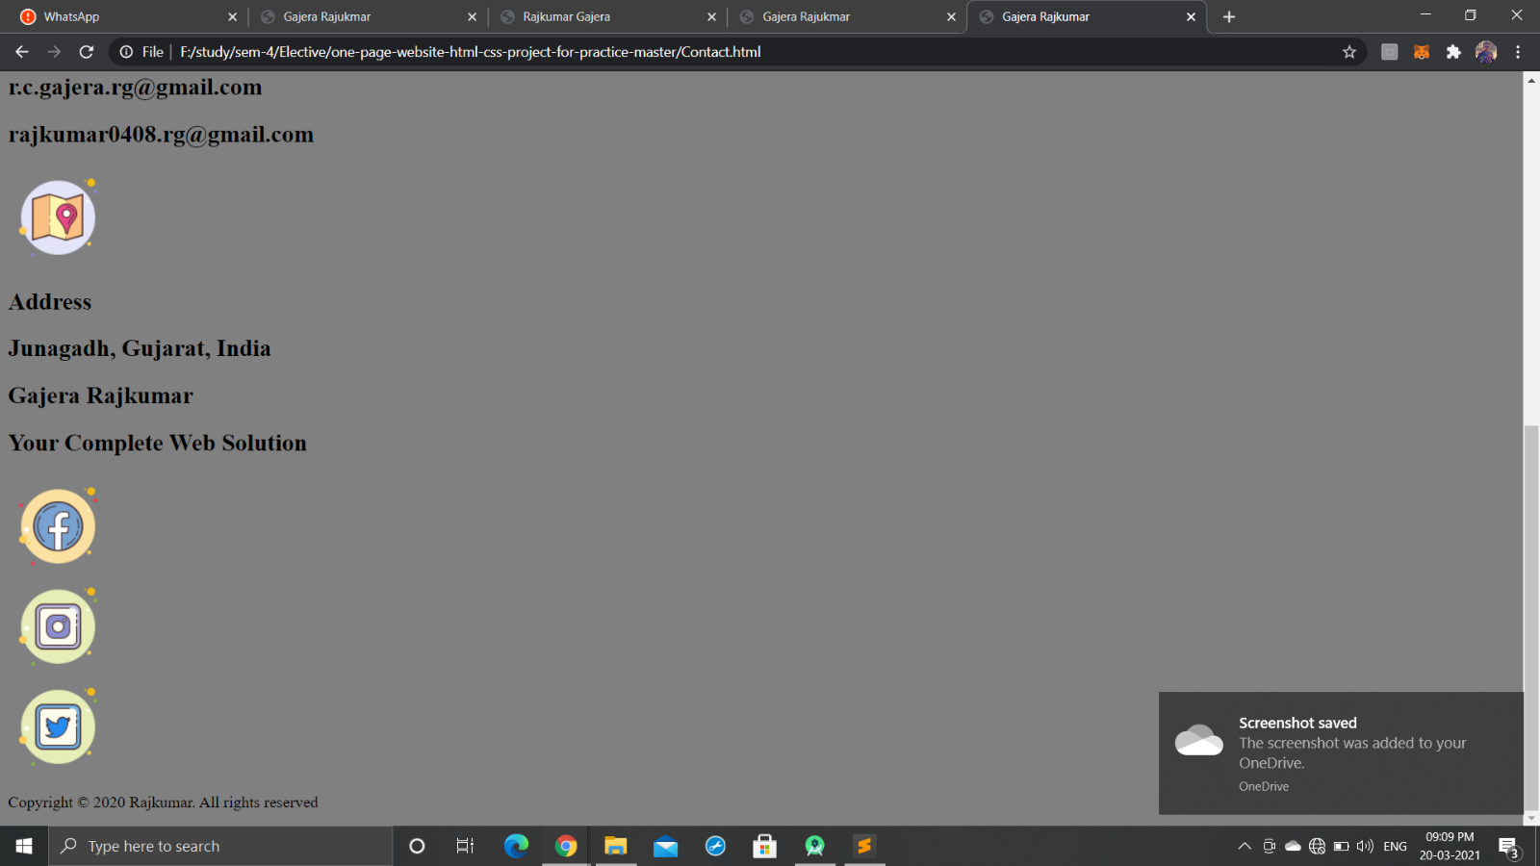

**Assignment-2**

**AIM:** Create an external style sheet (.css document) with at least eight different CSS rule sets (consisting of a selector and declaration block). Link the style sheet to all of your above original HTML pages. Your CSS style rules should specify font family and font size for paragraph and heading text; link states including link, visited, hover, and active. You should specify either a background image or background color for your pages and style some other aspect of the CSS box model, such as border, margin, or padding. In addition, create two or more class attributes somewhere in your HTML that are targeted and styled with CSS and create an id attribute somewhere in your HTML that is targeted and styled with CSS. Finally, you should incorporate the CSS float property into your styles in some way and clear it where appropriate.

